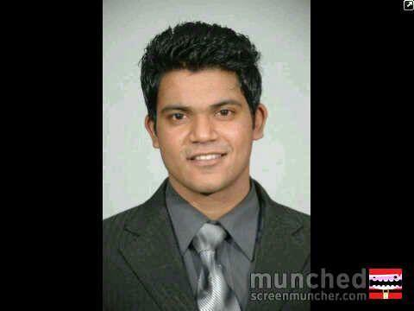

______________________________________________________________________

Name : **V. KALYANARAMAN**

Residence Address : No.9, First Floor, Dronagiri CHS

Lokmanya Nagar Pada No.2

Jekegram Post

THANE (W) – 400606.

M +91 987 088 8911

E: [prvnvnkt8@gmail.com](mailto:prvnvnkt8@gmail.com) /[rvbombay1231@gmail.com](mailto:rvbombay1231@gmail.com)

Date of Birth : 09/06/1993

Height & Weight : 174 cms & 62 kgs

Languages Known : English, Hindi, Marathi & Tamil

Vision & Career Objective : To see myself as a successful F&B Manager

Mission : Passion for Performance

Preferred Area for Employment : **Food & Beverage Service**

Name of the Instituition : Anjuman-I-Islams’s Institute of Hotel Management and

Catering Technology, Mumbai.

**Academic Qualifications** : **B.Sc (Hospitality Studies) from Mumbai University**

|  |  |  |  |
| --- | --- | --- | --- |
| Exam | Board/University | Year | Class |
| T.Y.B.Sc. (HS) | University of Mumbai | 2012-2013 | Second |
| S.Y.B.Sc. (HS) | University of Mumbai | 2011-2012 | Second |
| F.Y.B.Sc. (HS) | University of Mumbai | 2010-2011 | Second |
| H.S.C | Maharashtra State Board | 2009-2010 | First |
| S.S.C | Maharashtra State Board | 2007-2008 | Second |

**Trainee Café Manager** (Operations) with F&B Retail **Café Coffee Day** from 3.6.2013 to 10.7.2014

* Interacting With Customers and Customer Service
* QSR Operations
* SOP compliance
* Preparation and serving coffee, food and other beverages
* Cashiering, stock management ,inventory control
* Opening closing of café(rotating shifts 10 hours)
* Team handling
* Learning & Development
* Wastage control measures
* Maintaining café hygiene in the premises of the café etc.

**Assistant Restaurant Manager** with a chain of branded restaurants viz. Poptates', Urban Tadka,

and Timbuctoo from 21.7.2014 till 28.2.2017 at various locations in Mumbai

Reporting to the Restaurant Manager & Area Manager and assist in managing the day-to-day op. of the F&B outlet. Core Responsibilities:

* Closing and opening of the Restaurant
* Responsible for assigned shift, assisting in overall management.
* Positive relationships with customers ,team members, and vendors
* Ensures product quality and great service.
* Assist in maintenance of the restaurant
* Learning Profit & Loss responsibility under the training of RM
* Basic computer literacy
* Overseas the dining area, supervises food and beverage service staff in accordance with operating policies
* Positive guest relations.
* Ensures company standards on equipment, facility

**Restaurant Manager** from 1.3.2017 till 17.3.2019

**Promoted as Unit Manager w.e.f. 18.3.2019 -** Responsible for 2 outlets in same premises.

INDUSTRIAL EXPOSURE:

|  |  |
| --- | --- |
| * ITC Grand Central Hotel – 6 months   Food & Beverage Service, Front Office, Training Department and Housekeeping | 2011 |

* Have successfully completed Customer Service Certification program

CULTURAL ACTIVITIES:

|  |
| --- |
| * Functioned as a Member of Cultural Dept for Magn 2K11 * Won 2nd price in Tug-of-War held during the Annual College Sports Day, 2012 * Functioned as a Food Production for Valedictory Eve 2012 |

Personal Traits: Passionate for Hospitality

Dedication to providing exceptional customer service

Thirst for knowledge

REFERENCES:

1. C.A Meenakshi Sundaresan

Tax Consultant, EY India.

M: +91 9967035521

1. Mr. Uday Nambiar

M: +91 8976817162

Role / designation: Restaurant Manager/Hotel Manager

Experience: 4.5 years

4 YEARS IN THE FOOD AND BEVERAGE, CULINARY area.

Functional Area: Hotels/Restaurants/Airlines/Railways

Education: BHM Hotel Management